BETWEEN CLAUSE:
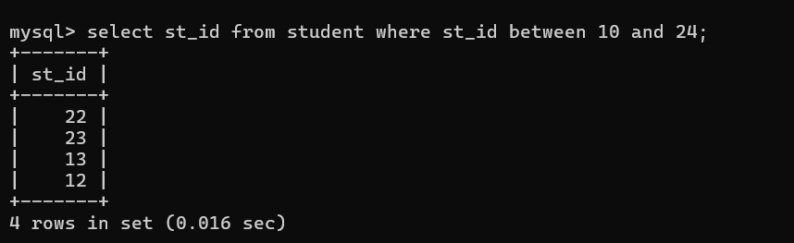
IN CLAUSE:
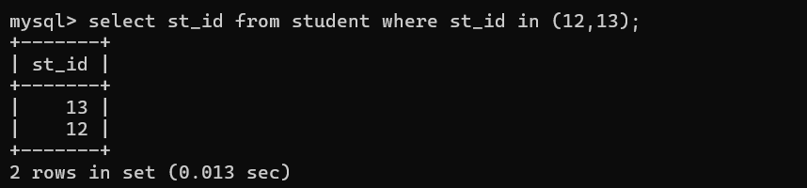
AGGREGATE FUNCTION:
